**DevOps Assignment**

**Q1. Describe the usage of the git stash command by using an example and also state the process by giving the screenshot of all the commands written in git bash.**

-> git stash temporarily shelves (or stashes) changes you've made to your working copy so you can work on something else, and then come back and re-apply them later on. Stashing is handy if you need to quickly switch context and work on something else, but you're mid-way through a code change and aren't quite ready to commit.

**Example:** Disha and Vedant are working on a website . Disha is working on the home page and vedant is working on some other page .Disha has some uncommitted changes and she wants to check the progress of vedant’s work but she doesn’t want to commit yet as the code is incomplete.So in this case she can stash current changes and switch to vedant’s branch to check the progress .After that she can come back and take the changes from the stash stack and resume her work.

**1. Git stash push -m “message”** : used to create a stash.

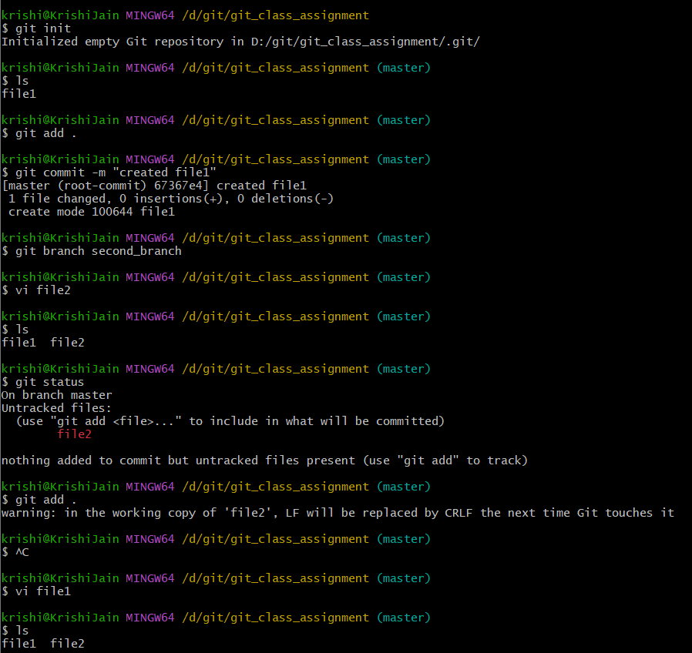

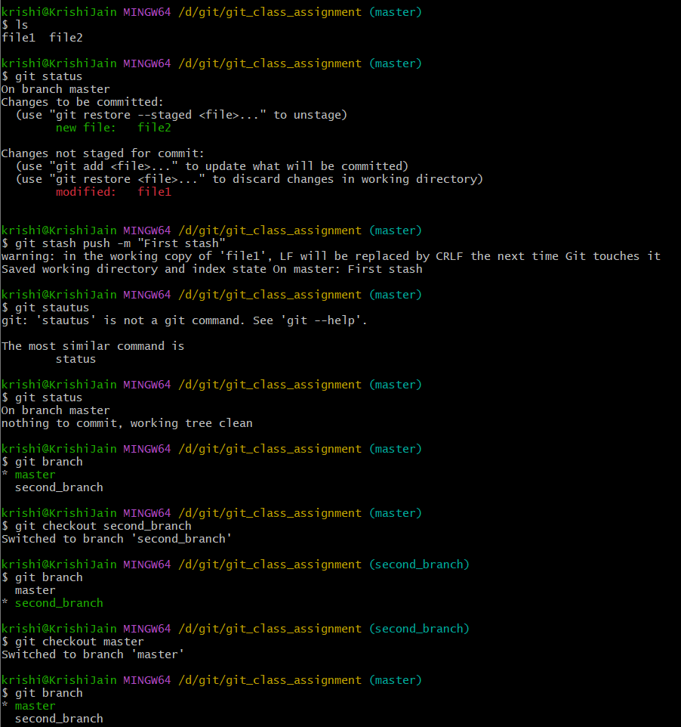

**2. Git stash list :** Will list the all of the stashes that’ve been created.

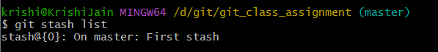

**3. Git stash show [—index]:** Shows the changes lines in that particular stash with respective to the files.

If you don’t give the index it’ll take the 0.

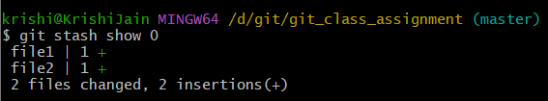

**4. Git stash apply [—index]:** is used to get and apply the changes the of a particular stash .

**This will keep the stash in stack.

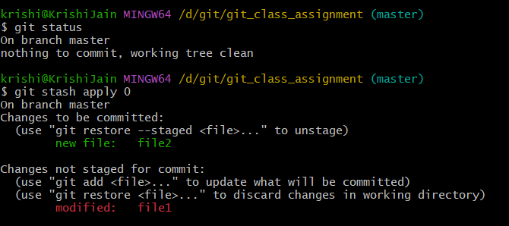

**5. Git stash pop [—index]:** is used to get and apply the changes the of a particular stash .

It’ll will remove that particular stash from the stack.**This will remove the stash in stack.

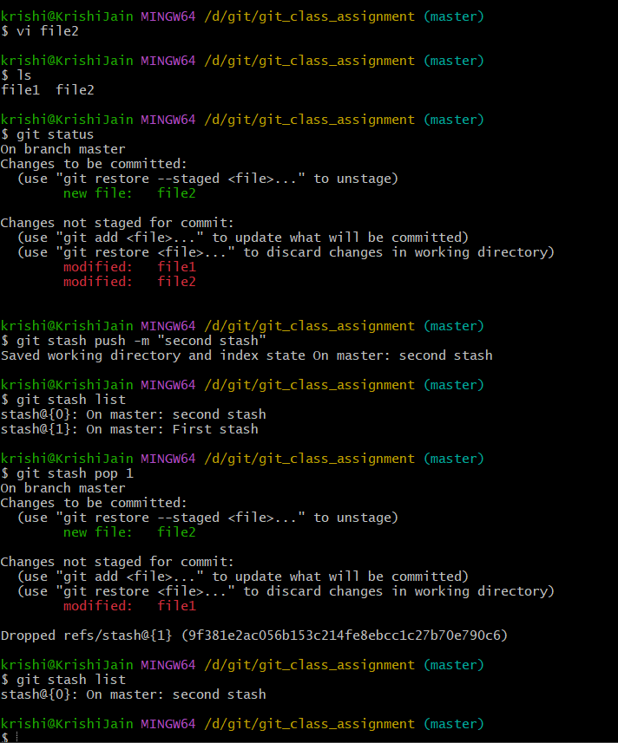

**6.Git stash drop:** Used to drop/pop a particular stash from the stack

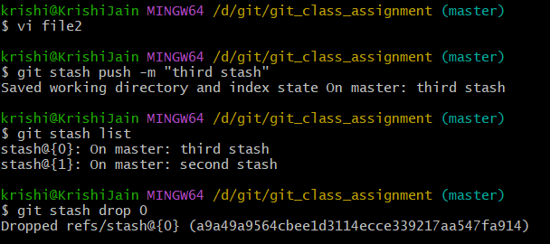

**7. Git stash clear:** This will remove all the stashes from the stack.

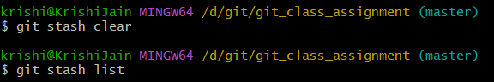

**Q2. By using a sample example of your choice, use the git fetch command and also use the git merge command and describe the whole process through a screenshot with all the commands and their output in git bash.**

**->Git fetch :** The git fetch command downloads commits, files, and refs from a remote repository into your local repo. Fetching is what you do when you want to see what everybody else has been working on. Git fetch downloads but it won’t merge .

**->Git merge:** Merging is Git's way of putting a forked history back together again. The git merge command lets you take the independent lines of development created by git branch and integrate them into a single branch.

**For Example:** We are creating a repository in the git hub and cloning it to the local then we will make a new branch in the remote and create a commit in that and fetch that update by git fetch as we know that it only downloads that update/commit but does not merge, so we will use git merge to merge that updated branch with the local repository.

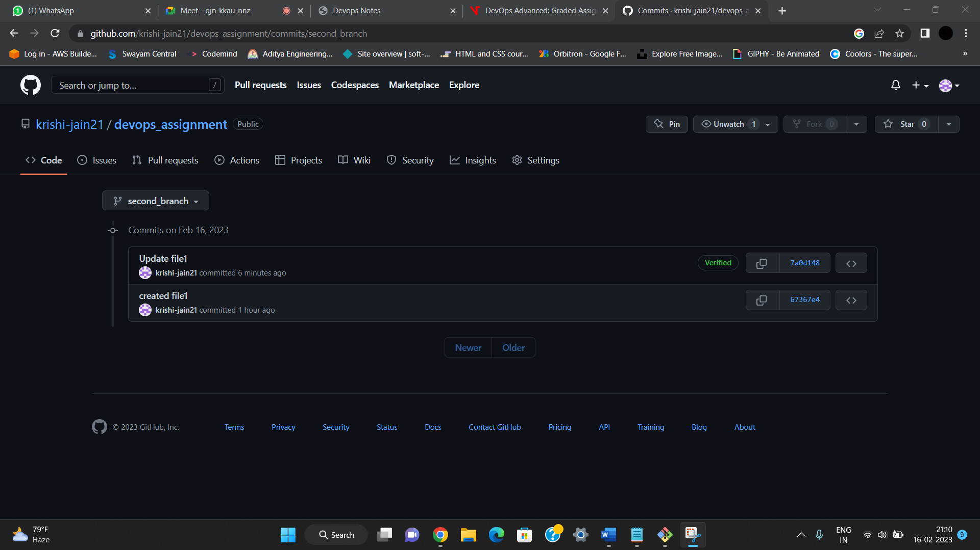

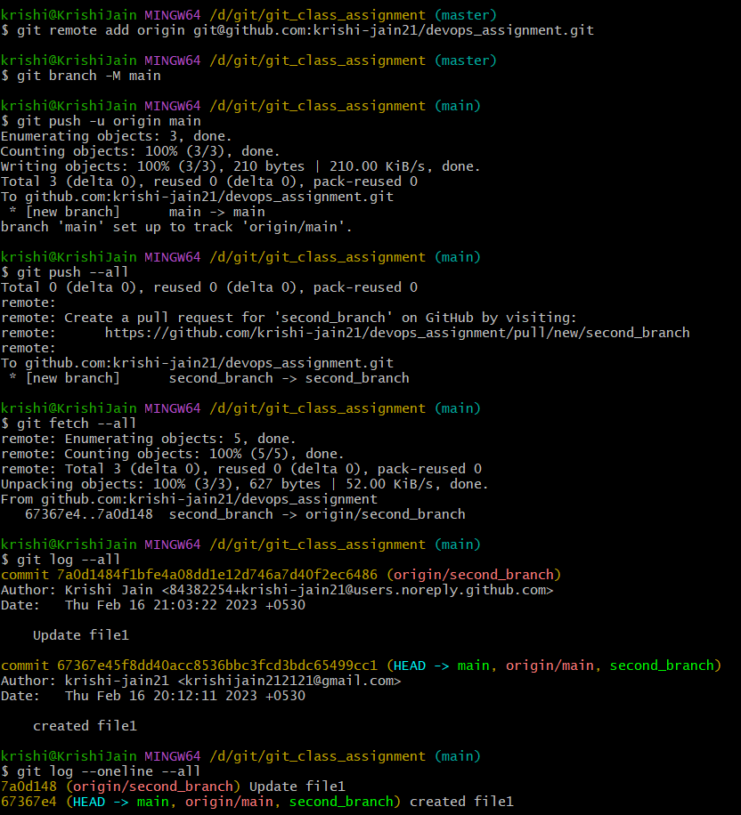

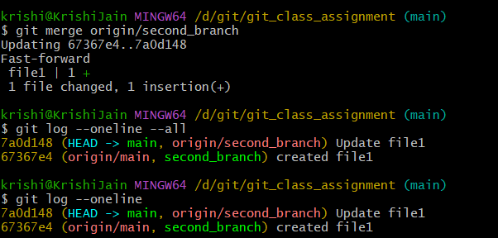

**Q3. State the difference between git fetch and git pull by doing a practical example in your git bash and attach a screenshot of all the processes.**

->**Git fetch** :The git fetch command downloads commits, files, and refs from a remote repository into your local repo. Fetching is what you do when you want to see what everybody else has been working on. It’s similar to svn update in that it lets you see how the central history has progressed, but it doesn’t force you to actually merge the changes into your repository. Git isolates fetched content from existing local content; it has absolutely no effect on your local development work. Fetched content has to be explicitly checked out using the git checkout command. This makes fetching a safe way to review commits before integrating them with your local repository.

->**Git pull**:The git pull command first runs git fetch which downloads content from the specified remote repository. Then a git merge is executed to merge the remote content refs and heads into a new local merge commit.

**Git Fetch is the command that tells the local repository that there are changes available in the remote repository without bringing the changes into the local repository. Git Pull on the other hand brings the copy of the remote directory changes into the local repository.

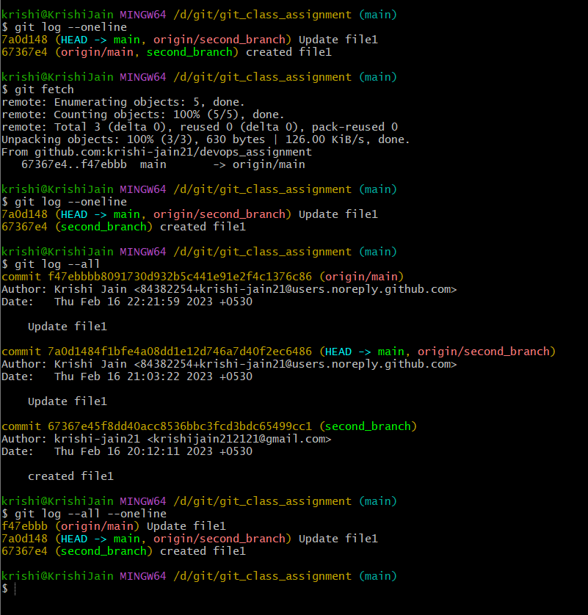

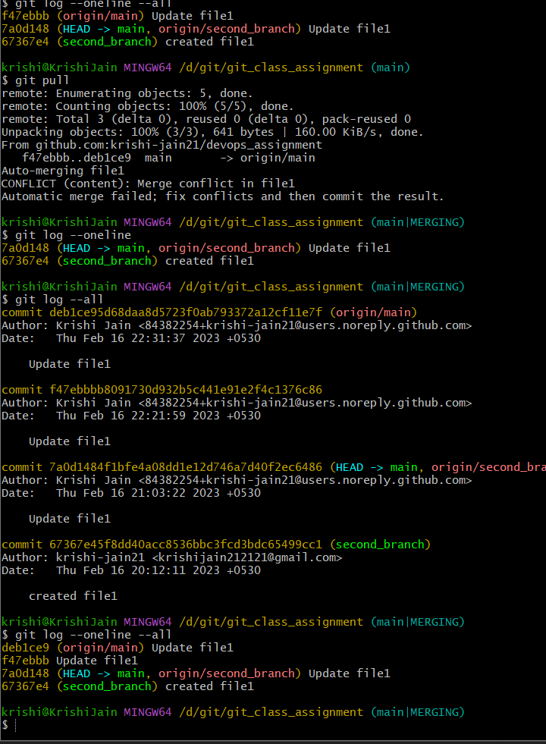

**Q4. Try to find out about the awk command and use it while reading a file created by yourself. Also, make a bash script file and try to find out the prime number from the range 1 to 20.**

->**awk command**:AWK is suitable for pattern search and processing. The script runs to search one or more files to identify matching patterns and if the said patterns perform specific tasks. In this guide, we take a look into AWK Linux command and see what it can do.

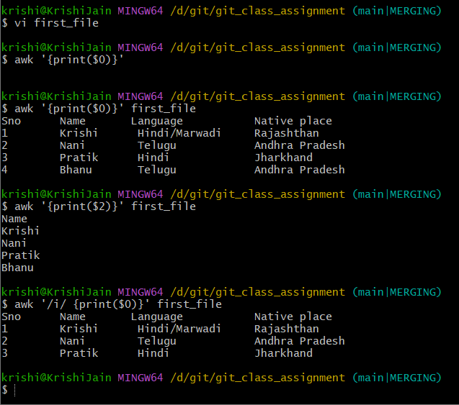

**Program to print primes between 1 to 20:**



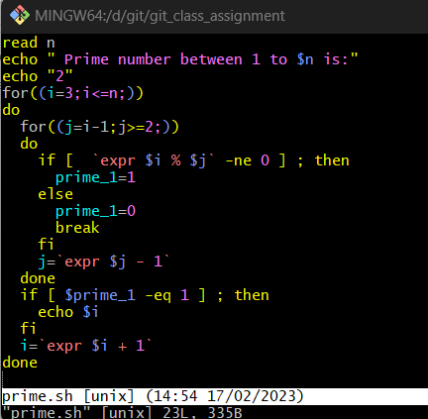

**Output:**

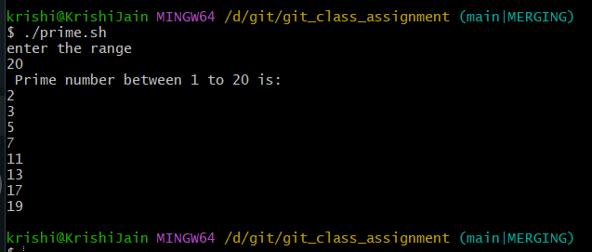

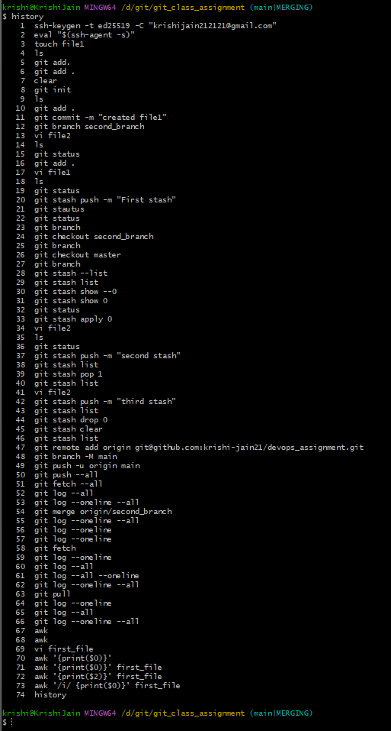**History command**: Linux history command is used to display the history of the commands executed by the user.

**Q5. Set up a container and run a Ubuntu operating system. For this purpose, you can make use of the docker hub and run the container in interactive mode.**

🡪Docker pull is used to get an image from docker hub so here we use “docker pull ubuntu:latest “

🡪This will get the latest image of ubuntu from dockerhub.To run ubuntu container we use “docker run -ti ubuntu /bin/bash“.

🡪This will open an interactive terminal of ubuntu container that started .

